**Final Project Report**

**AudioCloud**



**Project Supervisor**

**Muhammad Saeed Amjad**

**Submitted By**

**S19020E3FC**

Mubashir Iqbal BC140400342

Arslan Maqbool BS140401325

**Software Projects & Research Section,**

**Department of Computer Sciences,**

**Virtual University of Pakistan**

|  |
| --- |
|  |



**CERTIFICATE**

This is to certify that Mubashir Iqbal (BC140400342), Arslan Maqbool (BS140401325) have worked on and completed their Software Project at Software & Research Projects Section, Department of Computer Sciences, Virtual University of Pakistan in partial fulfillment of the requirement for the degree of BS in Computer Sciences under my guidance and supervision.

In our opinion, it is satisfactory and up to the mark and therefore fulfills the requirements of BS in Computer Sciences.

**Supervisor / Internal Examiner**

Muhammad Saeed Amjad

Supervisor,

Software Projects & Research Section,

Department of Computer Sciences

Virtual University of Pakistan

___________________

(Signature)

**External Examiner/Subject Specialist**

<<External Supervisor Name>>

___________________

(Signature)

**Accepted By:**

**_____________**

(For office use)

**EXORDIUM**

**In the name of Allah, the Compassionate, the Merciful.**

**Praise be to Allah, Lord of Creation,**

**The Compassionate, the Merciful,**

**King of Judgment-day!**

**You alone we worship, and to You alone we pray for help,**

**Guide us to the straight path**

**The path of those who You have favored,**

**Not of those who have incurred Your wrath,**

**Nor of those who have gone astray.**

**DEDICATION**

**We are dedicating this thesis to our beloved people who have meant and continue to mean so much to us. Although they are no longer of this world, their memories continue to regulate our life. Whose love for us knew no bounds and, who taught us the value of hard work.**

**Thank you so much to them, we will never forget you all. Though your lives were short, we will make sure your memory lives on as long as we shall live. We love you all and miss you all beyond words. May Allah (SWT) grant you Jannah Firdous. Amen.**

**ACKNOWLEDGEMENT**

**We would first like to thank our thesis supervisor Muhammad Saeed Amjad of the Virtual University Pakistan. He was always available whenever we ran into a trouble spot or had a question about our research or writing. He consistently allowed this paper to be our own work, but steered us in the right direction whenever he thought we needed it.**

**Without his passionate participation and input, the validation survey could not have been successfully conducted.**

**Finally, we must express our very profound gratitude to our parents for providing us with unfailing support and continuous encouragement throughout our years of study and through the process of researching and writing this thesis. This accomplishment would not have been possible without them. Thank you.**

**Authors**

**[Mubashir Iqbal, Arsan Maqbool]**

**PREFACE**

**This thesis is written only to achieve our practical skills for writing reports and developing Coding skills and to experiment our skill level. We have made lot of struggle to make this project and report and worked hard days and night to make it happen.**

**TABLE OF CONTENTS**

|  |
| --- |
|  |

CHAPTER NO. 1

gathering & Analyzing info ……………………………………1

Introduction……………………………………………………………... 2

purpose……………………..……………………………………………... 2

scope……………………………………………………………………….. 2

definitions, acronyms and abbreviations…………………………….2

use cases and usage scenarios…………………………………………2

1.5.1 Use Case Diagrams…………………………………………………………......2

1.5.2 Usage Scenarios……………………………………………………………..…7

supplementary requirements………………………………………….11

1.6.1 Usability……………………………………………………………………...11

1.6.2 Reliability………………………………………………………………….....11

1.6.3 Supportability…………………………………………….…………………..11

1.6.4 System Requirements…………………………………….…………………..11

CHAPTER NO. 2

planning the project ……………………………………………..12

Introduction……………………………………………………………....13

Methodology……………………………………………………………...13

Available Methodologies…………………………………………….…13

Chosen Methodology……………………………………………………13

Reasons for Chosen Methodology……………………………….…..14

Work Plan…………………………………………………………….........14

Project Structure…………………………………………………..……15

* + 1. Team Structure……………………………………………………………….....15
    2. Project Schedule (Submission Calendar) ……………………………………..15

CHAPTER NO. 3

designing the project …………………………………………….16

Introduction…………………………………………………………….…17

purpose……………………………………………………………………..17

scope………………………………………………………………………..17

definitions, acronyms and abbreviations …………………………..17

Architectural Representation (Architecture Diagram)………...17

Dynamic Model: Sequence Diagrams………………………………...18

Object Model/Logical Model: Class Diagram………………..…..26

Database Model (Database Diagram)…………………………..…….27

Graphical User Interfaces………………………………………..……28

Chapter no.4

DEvelopment ……………………………………………………….…..44

Development plan (Architecture Diagram)…………………….…...45

**CHAPTER 1**

Gathering & Analyzing Info

1.1 Introduction

Data collection is the process of gathering and measuring information on variables of interest, in an established systematic fashion that enables one to answer stated research questions, test hypotheses, and evaluate outcomes.

The purpose of analyzing data is to obtain usable and useful information. The analysis, irrespective of whether the data is qualitative or quantitative, may:

* Describe and summaries the data
* Identify relationships between variables
* Compare variables
* Identify the difference between variables
* Forecast outcomes

1.2 purpose

The purpose of information gathering is to support the planning of your organization's work to become more fully inclusive. It is important to look at available facts, objective information, including demographics and best practices. It is also important to look at stakeholder perspectives, subjective information, including the opinions of your clients, potential clients, staff, board members, donors, etc. regarding the work that you do and how you do it.

1.3 scope

The aim of this project is to develop a website named as audio cloud. Basic scope of this project is to provide a platform for people to upload, download and share their audio files of different categories to other people. Users can share audio files of this platform to social media like Facebook, Twitter, WhatsApp, etc. Users will be able to search, play audio file online, like/dislike, share and download all public audio files. Users can create and manage their playlists of their favorite audio files.

1.4 definitions, acronyms and abbreviations

Nill

1.5 use cases and usage scenarios

1.5.1 Use Case Diagrams

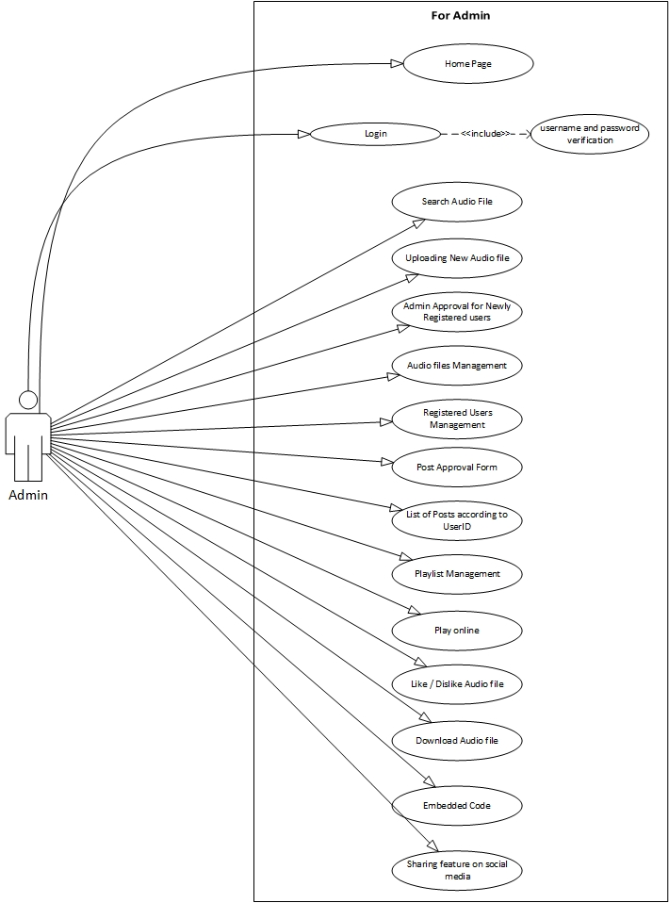

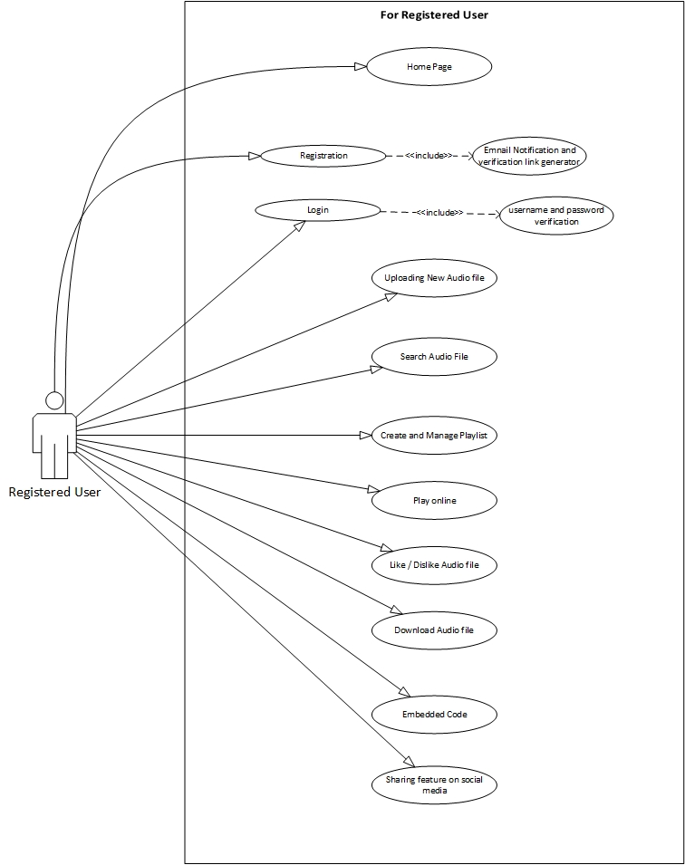

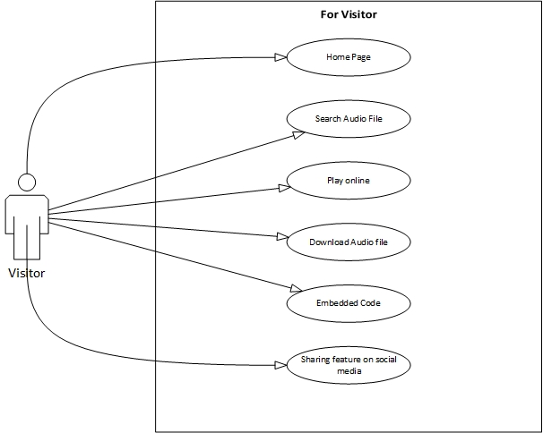



1.5.2 Usage Scenarios

1. **Home Page**

|  |  |
| --- | --- |
| Use Case Title | Home Page |
| Use Case ID | audioCloud_main() |
| Actions | Search first 30 audio files according to newly uploaded, listen count and like |
| Description | This is the main webpage of the website, which have navigation links, search box, login and register link. There are 30 latest audio files shown on this page for visitors. |
| Alternative Paths | Nil |
| Pre Conditions | Server and Website is in running condition |
| Post Conditions |  |
| Author | **S19020E3FC** (BC140400342,BS140401325) |
| Exceptions | Nill |

1. **Registration**

|  |  |
| --- | --- |
| Use Case Title | Registration |
| Use Case ID | Register_newUser() |
| Actions | 1. User must fill all required fields in registration form 2. Information should be stored in database table 3. Send email verification link to the given user email address 4. Show successful registration message and ask for verification |
| Description | This webpage gets the user information like username, first and last name, email , password and store this information to database |
| Alternative Paths |  |
| Pre Conditions | Website is in running condition and proper interface for registration is available. |
| Post Conditions | All required fields are filled with proper information |
| Author | S19020E3FC (BC140400342,BS140401325) |
| Exceptions | Missing field information, Password is less than 6 digits, password and confirm password did not match |

1. **Login**

|  |  |
| --- | --- |
| Use Case Title | Login |
| Use Case ID | User_Login |
| Actions | Login the user to platform |
| Description | This module checks the username and password of a user to give him the registered user access. |
| Alternative Paths | If username does not exist in database or password is incorrect then an error is prompted on screen that username and password did not match, There is also a “Forget Password” page to recover the password of existing account |
| Pre Conditions | A user is already registered and proper interface for login is available. |
| Post Conditions | If a user enters correct username with correct password then he/she will get the registered user rights access |
| Author | S19020E3FC (BC140400342,BS140401325) |
| Exceptions | User Name and password did not match |

1. **Uploading New Audio File**

|  |  |
| --- | --- |
| Use Case Title | Uploading New Audio File |
| Use Case ID | uploading_newFile() |
| Actions | Upload an audio file to the platform with given information from authorized register user |
| Description | This webpage gets the information about the audio file like title, description, category, etc and audio file from user and store this information in database and audio file in audioBank folder |
| Alternative Paths |  |
| Pre Conditions | User must login to get access to this webpage |
| Post Conditions | Page refresh with confirmation of uploading to audio file. |
| Author | S19020E3FC (BC140400342,BS140401325) |
| Exceptions | If a file is not uploaded properly, then a prompted message is show on user screen about this error and ask him/her to try again. |

1. **Search Audio File**

|  |  |
| --- | --- |
| Use Case Title | Search Audio File |
| Use Case ID | Search_AudioFile() |
| Actions | Search audio files in the database according to title, uploading date and category. Also sort the result of database according to listen count, likes and length of audio file |
| Description | This webpage show the results of give searched word from user according to the given method like with title, uploading date or category |
| Alternative Paths |  |
| Pre Conditions | Server and Website should be running in proper way |
| Post Conditions | Show the results of search words |
| Author | S19020E3FC (BC140400342,BS140401325) |
| Exceptions | If the searching words are not present in database, no audio file is shown on result page |

1. **Create and Mange Playlist**

|  |  |
| --- | --- |
| Use Case Title | Create and Manage Playlist |
| Use Case ID | playlist_management() |
| Actions | Create new playlist and add audio files in it or do some changes in existing playlist |
| Description | Through this module, a registered user can create and manage the existing playlist on the platform, A registered user can add new audio file and delete old file from the playlist. |
| Alternative Paths | Nill |
| Pre Conditions | A user should already login into platform. |
| Post Conditions | Showing updated playlist like audio file is deleted or new file is added. |
| Author | S19020E3FC (BC140400342,BS140401325) |
| Exceptions | Nill |

1. **Admin Approval for Newly Registered Users**

|  |  |
| --- | --- |
| Use Case Title | Admin Approval for Newly Registered users |
| Use Case ID | newUser_approval() |
| Actions | Admin can approve a user for uploading audio files |
| Description | This module is for admin. Through this module admin can approve a new user to authorize him/her to upload audio files on the platform. |
| Alternative Paths | Nill |
| Pre Conditions | New user is already verified his/her email address. |
| Post Conditions | A user is authorized for uploading audio files on the platform. |
| Author | S19020E3FC (BC140400342,BS140401325) |
| Exceptions | Nill |

1. **Post Approval**

|  |  |
| --- | --- |
| Use Case Title | Post Approval |
| Use Case ID | newPost_Approval() |
| Actions | Every public post needs attention of admin to approve it. So that, that post is shown on the platform to everyone. |
| Description | Through this module, Admin approve every new public post on the platform. |
| Alternative Paths | Nill |
| Pre Conditions | Authorized user uploaded an audio file. |
| Post Conditions | Post or Audio file is shown to every visitor of the platform. |
| Author | S19020E3FC (BC140400342,BS140401325) |
| Exceptions | Nill |

1. **Audio Files Management**

|  |  |
| --- | --- |
| Use Case Title | Audio Files Management |
| Use Case ID | file_manangement() |
| Actions | 1. Editing file title, description, etc 2. Editing uploaded User Credit about this file 3. Delete Audio file from the platform |
| Description | This is the admin module. Through this module admin can edit file title, description, etc including username which uploaded that file. |
| Alternative Paths | Nill |
| Pre Conditions | Admin login to platform |
| Post Conditions | Show updated platform to every one |
| Author | S19020E3FC (BC140400342,BS140401325) |
| Exceptions | Nill |

1. **Registered User Management**

|  |  |
| --- | --- |
| Use Case Title | Registered Users Management |
| Use Case ID | User_management() |
| Actions | 1. Change user account password 2. Edit user account information 3. Delete user account |
| Description | This is the admin module. Through this module, admin can change every possible thing about the user account. Admin can also delete the user account. |
| Alternative Paths | Nill |
| Pre Conditions | Nill |
| Post Conditions | Show updated platform to everyone. |
| Author | S19020E3FC (BC140400342,BS140401325) |
| Exceptions | Nill |

1. **List of Post according to UserID**

|  |  |
| --- | --- |
| Use Case Title | List of Posts according to UserID |
| Use Case ID | Postlist_with_UserID() |
| Actions | This is admin module. Through this module, Admin can view the post list through the user id. |
| Description | This module let the admin see all post of a user through his/her user id. This module also tells the likes, Dislikes, listen count and length of the audio file. |
| Alternative Paths | Nill |
| Pre Conditions | 1. Admin is logged in 2. Admin give id of any registered user |
| Post Conditions | Platform shows the list of post which a user posted according to date of posting |
| Author | S19020E3FC (BC140400342,BS140401325) |
| Exceptions | User id is not valid  User account is not approved for uploading |

1. **Play online**

|  |  |
| --- | --- |
| Use Case Title | Play Online |
| Use Case ID | onlinePlayer() |
| Actions | Get file from the platform and play on web browser on end user side |
| Description | Through this module an online audio player is added on end user webpage and user can play any audio file of the platform through this player. |
| Alternative Paths | Nill |
| Pre Conditions | Web Server and Website is working properly |
| Post Conditions | Playing audio file at 70% loudness |
| Author | S19020E3FC (BC140400342,BS140401325) |
| Exceptions | Nill |

1. **Liking or Disliking Audio File**

|  |  |
| --- | --- |
| Use Case Title | Like / Dislike Audio File |
| Use Case ID | Like_Dislike() |
| Actions | Increase the number of like and dislike of the audio file |
| Description | This function is used by admin and registered user only to like and dislike any public audio file of the platform |
| Alternative Paths | Nill |
| Pre Conditions | User or admin is logged in to the platform |
| Post Conditions | Show the updated like or dislike count to the users |
| Author | S19020E3FC (BC140400342,BS140401325) |
| Exceptions | Nill |

1. **Downloading Audio File**

|  |  |
| --- | --- |
| Use Case Title | Download Audio File |
| Use Case ID | Download() |
| Actions | Send selected audio file to the end user |
| Description | This option is available to every user either it is a registered user or a visitor to download the desired audio file |
| Alternative Paths | Nill |
| Pre Conditions | Clicked on the download icon |
| Post Conditions | File is downloaded to the user browser |
| Author | S19020E3FC (BC140400342,BS140401325) |
| Exceptions | Nill |

1. **Embedding Code**

|  |  |
| --- | --- |
| Use Case Title | Embedded Code |
| Use Case ID | Embedded_Code_Generator() |
| Actions | Option to give the embedded code to the end user to share the audio file to other website |
| Description | This option gives the embedded code of the audio file of the platform to the user. So that, the user share it on some other website |
| Alternative Paths | Nill |
| Pre Conditions | Nill |
| Post Conditions | Copy the embedded code to the user’s computer clip board. |
| Author | S19020E3FC (BC140400342,BS140401325) |
| Exceptions | Nill |

1. **Sharing feature on Social Media**

|  |  |
| --- | --- |
| Use Case Title | Sharing feature on Social Media |
| Use Case ID | Share_onSocialMedia() |
| Actions | Share the selected audio file to the selected social media like Facebook, Whatsapp, etc |
| Description | This function gives an option to the end user to share selected audio file to social media like Facebook, Whatsapp, etc |
| Alternative Paths | Nill |
| Pre Conditions | Nill |
| Post Conditions | Shared audio file to selected social media. |
| Author | S19020E3FC (BC140400342,BS140401325) |
| Exceptions | Nill |

1.6 supplementary requirements

1.6.1 Usability

This project Audio Cloud web based application is totally user friendly with very beautiful GUI frontend and very basic featured like users can perform tasks like playing the audio, uploading the audio or sharing the audio, liking and disliking within seconds without facing any issue.

1.6.2 Reliability

This web based application is very reliable and accurate in terms of tasks performed in it. This website is reliable enough to perform tasks which a user can demand.

1.6.3 Supportability

This website build on WampServer (Version 3.1.9) at local machine (Windows 10) as well as it can be run online on (Linux, Ubuntu, Window Server) with apache and mySql server configuration.

1.6.4 System Requirements

There is no specific system requirement for using this website. A Pentium-4 computer can also host this website with apache and mySql server configuration.

**CHAPTER 2**

Planning the Project

2.1 Introduction

This chapter contains the planning of the whole project that how we have planned about it like what methodologies we have used in it and what was the reason to choose specific methodology. This also contains project structure, work plan, team structure and project schedule

2.2 Methodology

Methodology is a term which is used for developing technique that what technique we use for software development.

2.3 Available Methodologies

A number of methodologies exist now a days and a variety of model used by various people to their need and nature of their work

2.4 Chosen Methodology

As per requirement, we will adopt the methodology named, “VU process model”. The description of which is given below:

**VU Process Model:-**

It is the combination of waterfall methodology and spiral methodology. It is also called hybrid approach of system development. It has five phases and which are Gathering and analyzing requirement, planning, analysis and design, development and final report.

In the requirement phase the system goals, services and constrains are established after discussion with user. The planning phase is synchronized effort to find all the potential roadblocks and draft a robust plan to tackle each. This phase usually involves a lot of brainstorming within software development team as well as with respective client. It maximizes the quality of system and minimizes any risks and errors.



2.5 Reasons for Chosen Methodology

Reason of choosing this methodology is that our project is divided already into different phases i.e. gathering and analyzing requirements phase, planning phase, analysis and design phase, development & final project report phase, and final report/viva phase. We will complete each phase in sequence and will submit it to our supervisor. He will suggest us about the improvement in each phase before starting the next phase. We will make improvement in that phase. This process will be adopted due to the spiral nature of VU Process model. When the phase is well-improved and well worked-out, and also accepted by our Supervisor then we will proceed to next phase. This will be done due to the waterfall nature of the VU Process model. Hence both models are suppressed in single form and that will be our VU process model. It will provide error free result as each step is done in a sequence.

2.6 Work Plan

This contains the whole work plan of our project like how many of the phases were and how much this project has taken time.

2.7 Project Structure

2.7.1 Team Structure

**Supervisor: Muhammad Saeed**

Group ID: **S19020E3FC**

Member 1: Mubashir Iqbal (BC140400342)

Member 2: Arslan Maqbool (BS140401325)

2.7.2 Project Schedule (Submission Calendar)

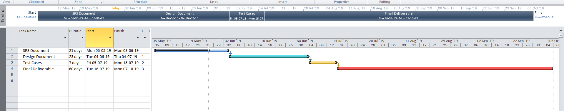

**CHAPTER 3**

Designing the Project

3.1 Introduction

Project design is an early phase of the project where a project's key features, structure, criteria for success, and major deliverables are all planned out. The point is to develop one or more designs which can be used to achieve the desired project goals.

3.2 purpose

The purpose of this phase is to design the architectural representation as well as diagrams. It also contains dynamic model or sequence diagrams, class diagrams, database diagram in it. It also contains graphical user interfaces of the platform.

3.3 scope

Project scope is the part of project planning that involves determining and documenting a list of specific project goals, deliverables, features, functions, tasks, deadlines, and ultimately costs. In other words, it is what needs to be achieved and the work that must be done to deliver a project.

3.4 definitions, acronyms and abbreviations

Nill

3.5 Architectural Representation (Architecture Diagram)



3.6 Dynamic Model: Sequence Diagrams















3.7 Object Model/Logical Model: Class Diagram



3.8 Database Model (Database Diagram)



3.9 Graphical User Interfaces

3.9.1 Home Page

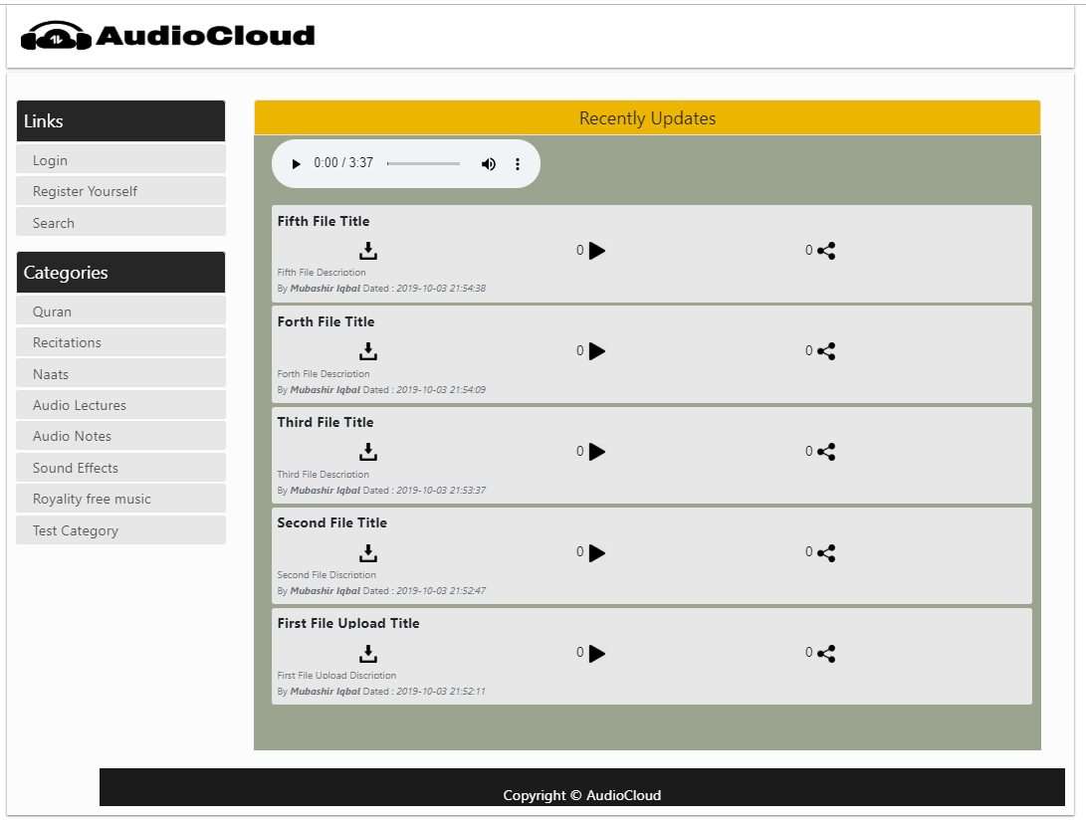

3.9.2 Registration Page

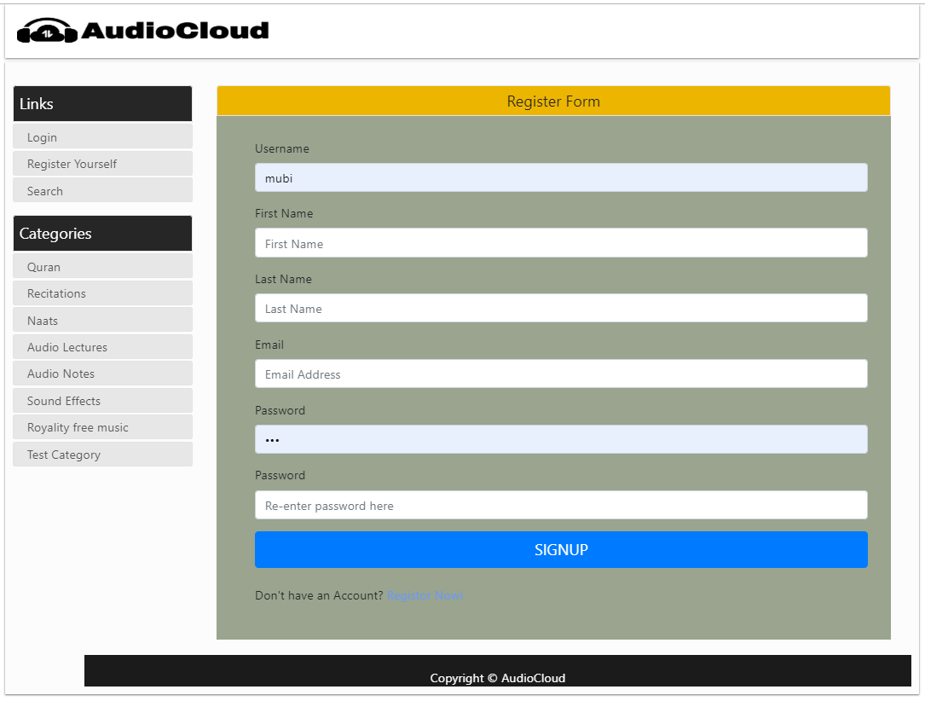

3.9.3 Login Page

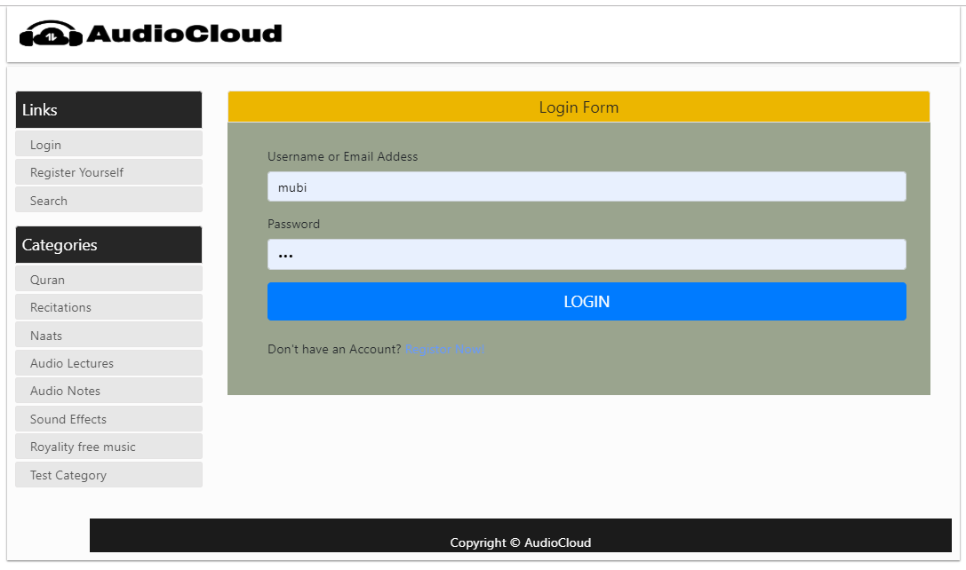

3.9.4 Search Page

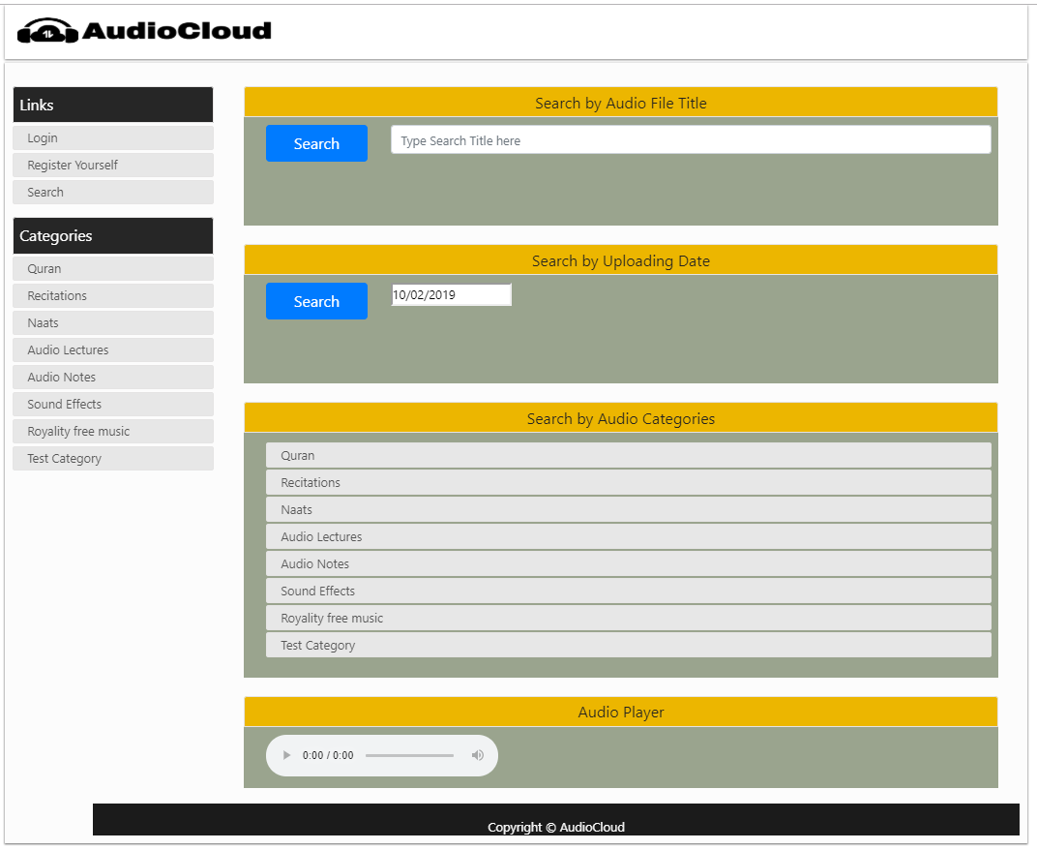

3.9.5 Search By Title Result Page

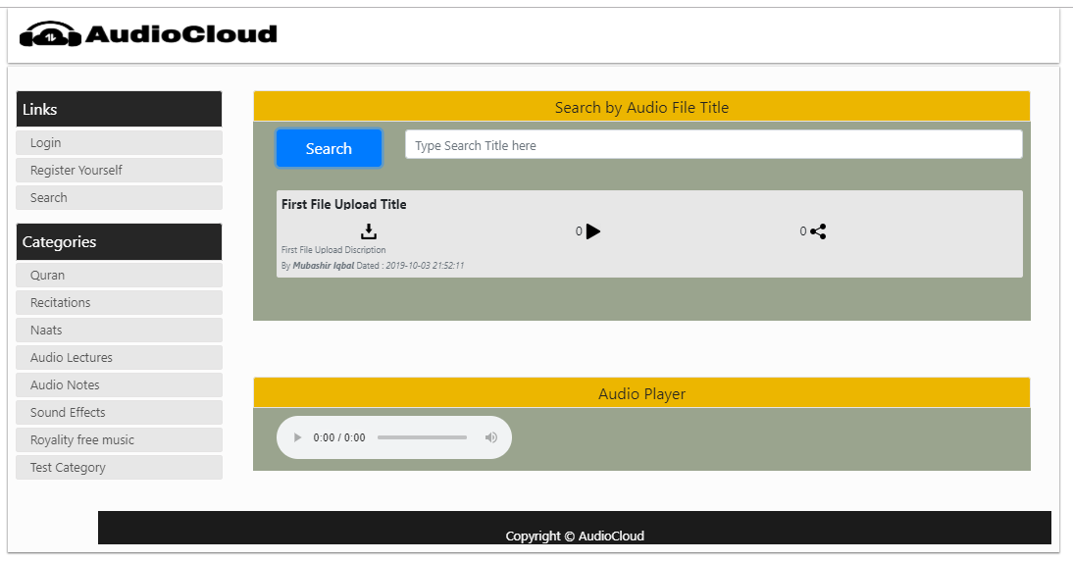

3.9.6 Search By Uploading Date Result Page

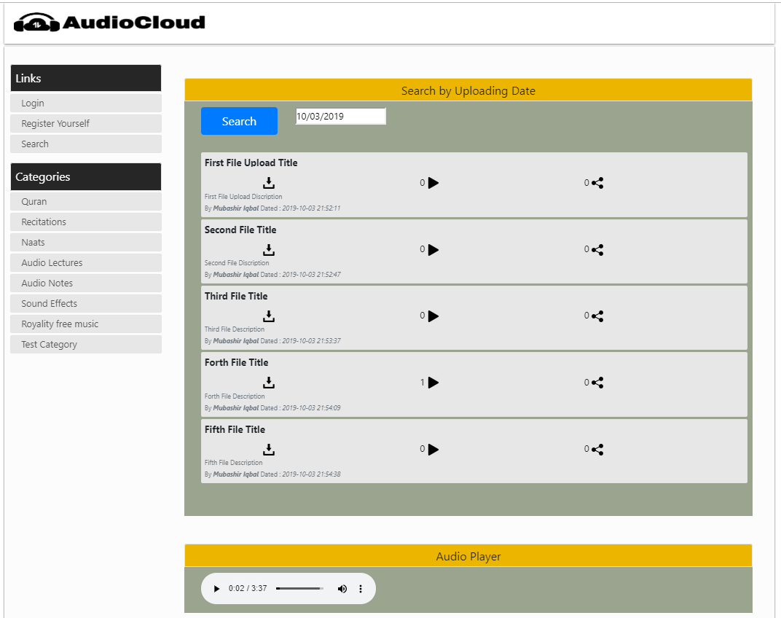

3.9.7 Search By Category Results Page

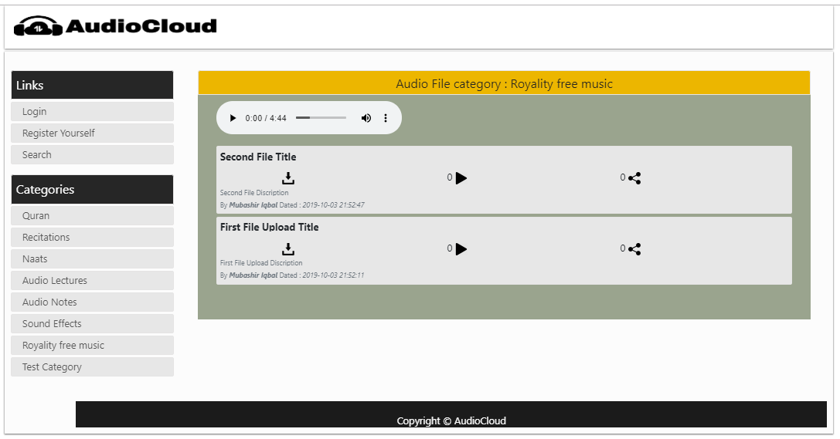

3.9.8 Logged In User Home Page

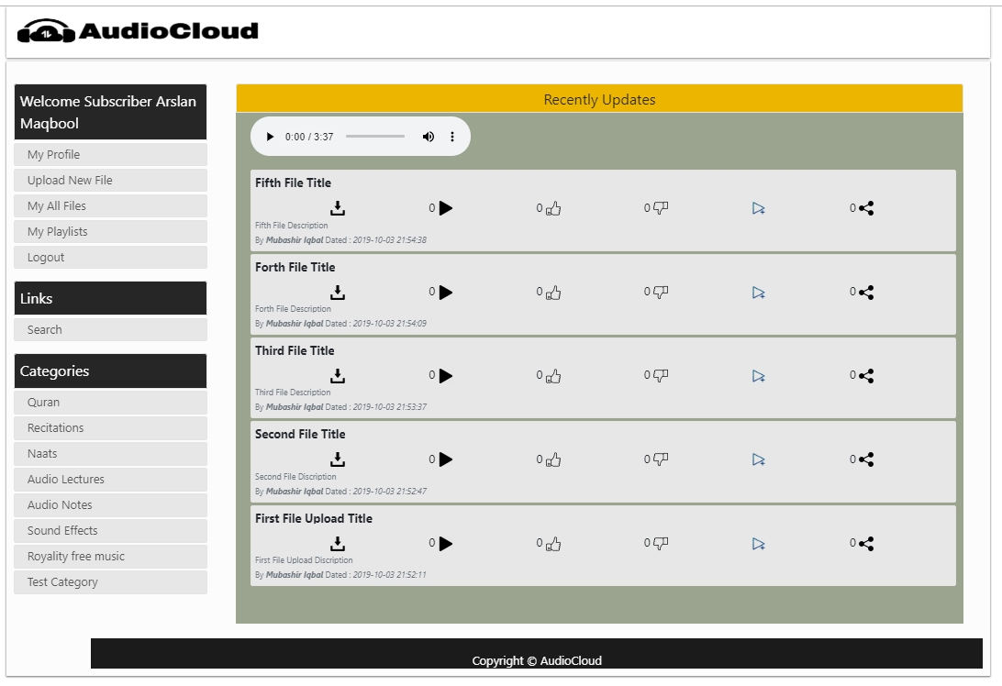

3.9.9 Logged In User Profile Page

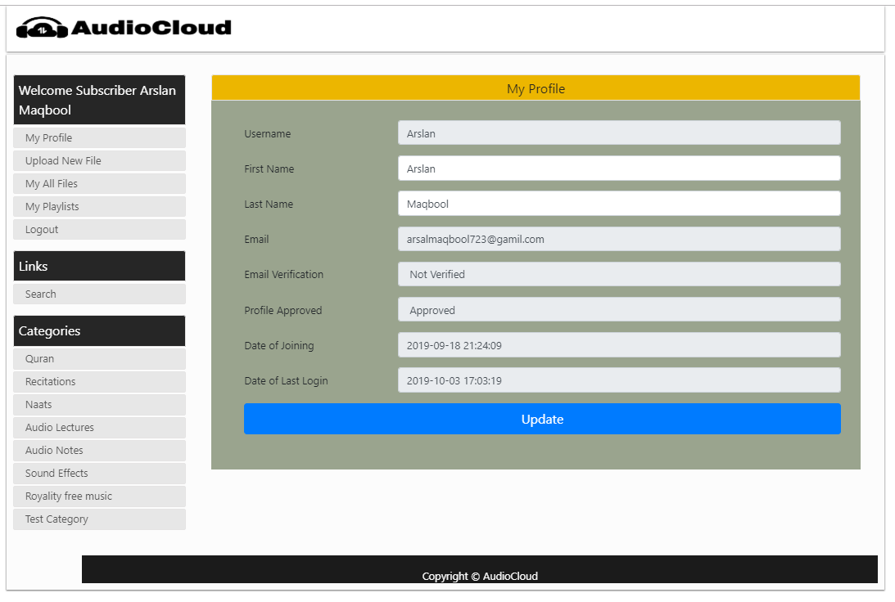

3.9.10 Logged In User New Audio File Uploading Page

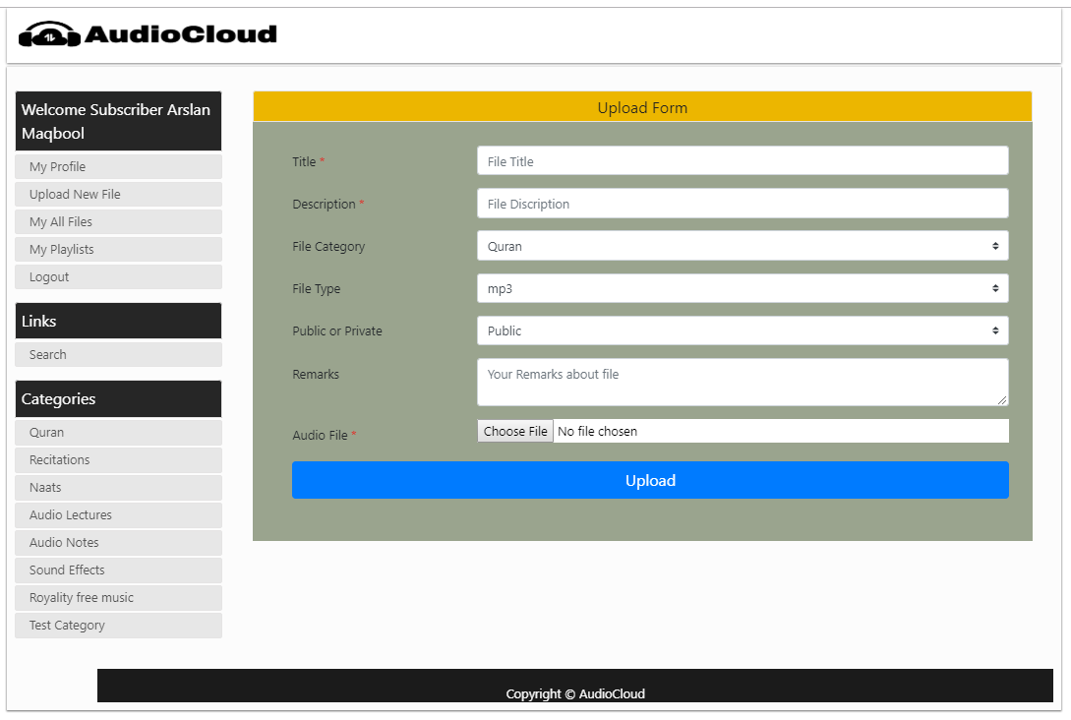

3.9.11 Logged In User My Playlists Page

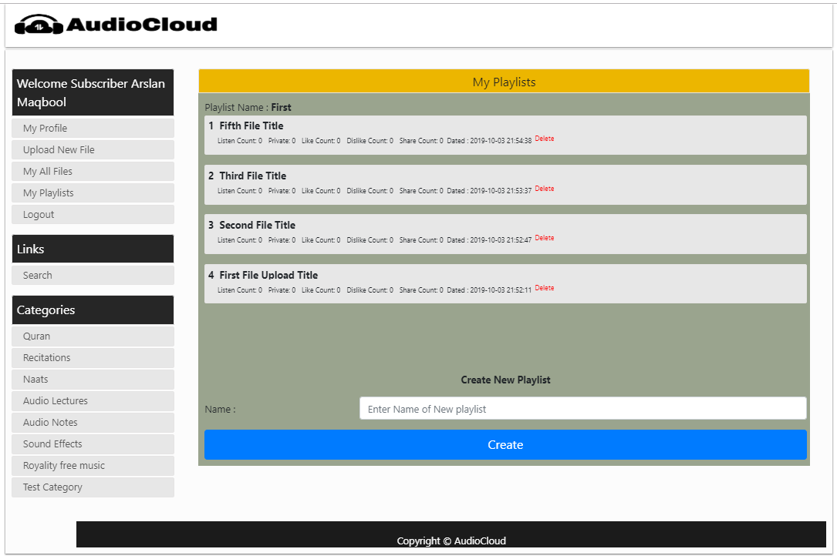

3.9.12 Logged In My All Posts Page

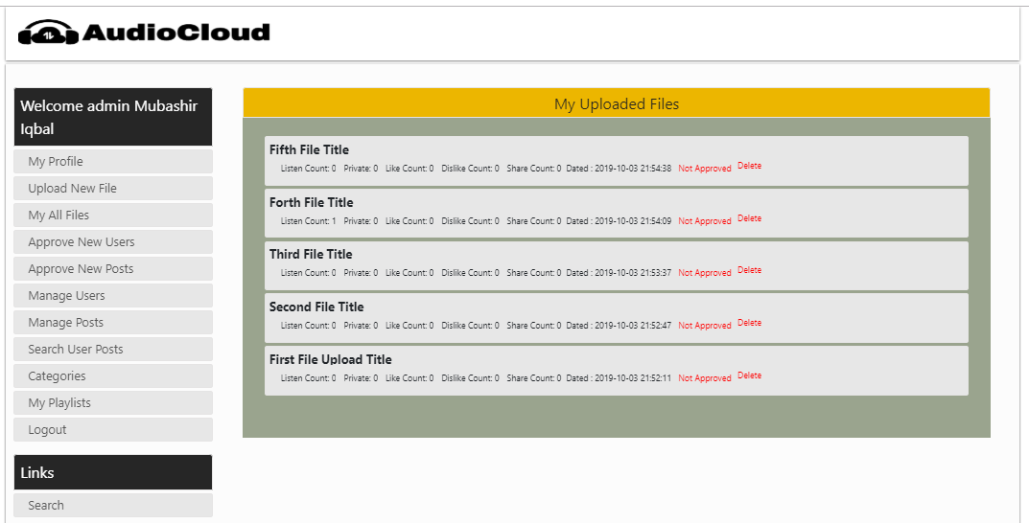

3.9.13 Admin Home Page

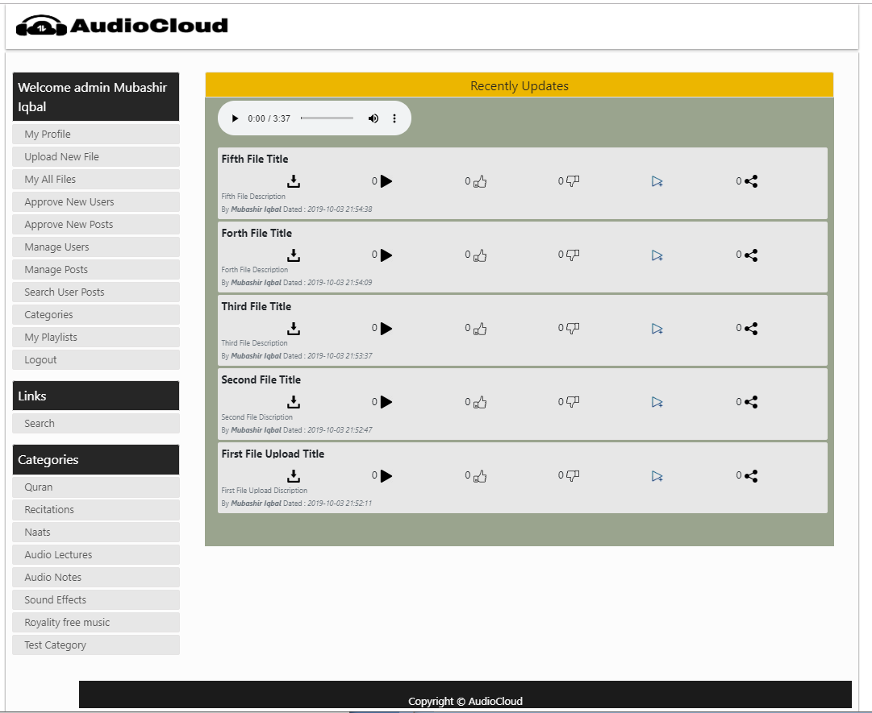

3.9.14 Admin Post Approval Page

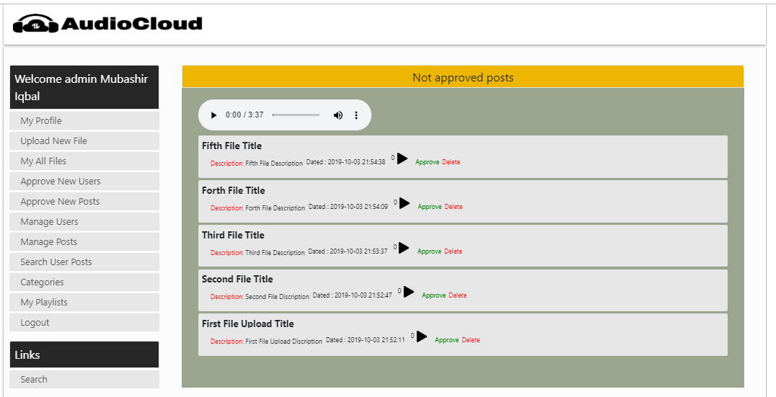

3.9.15 Admin User Approval Page

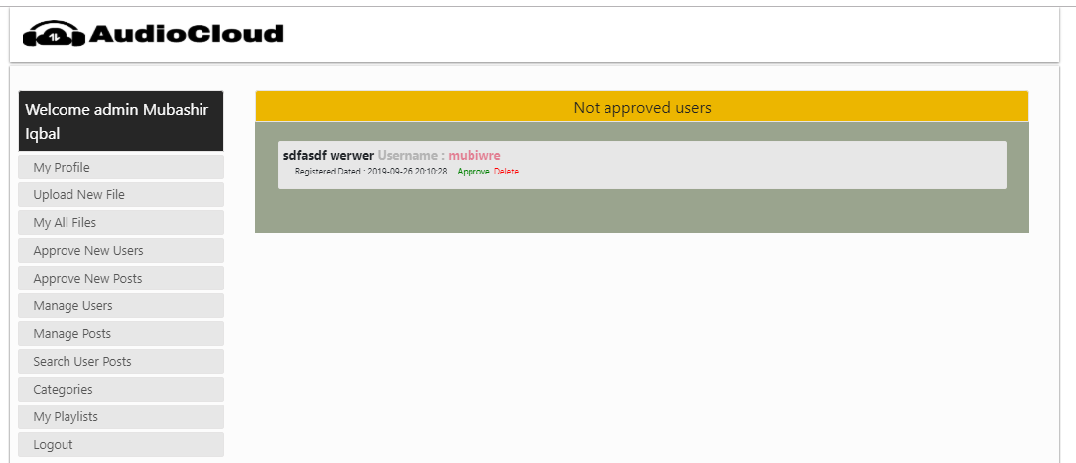

3.9.16 Admin Post Management Page

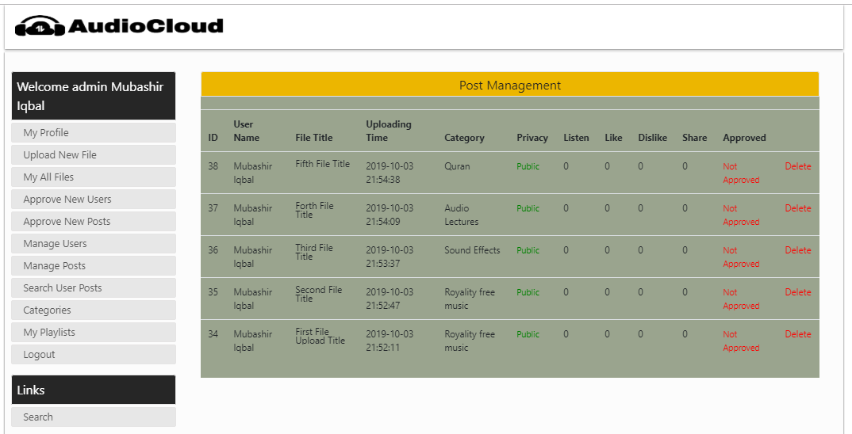

3.9.17 Admin User Management Page

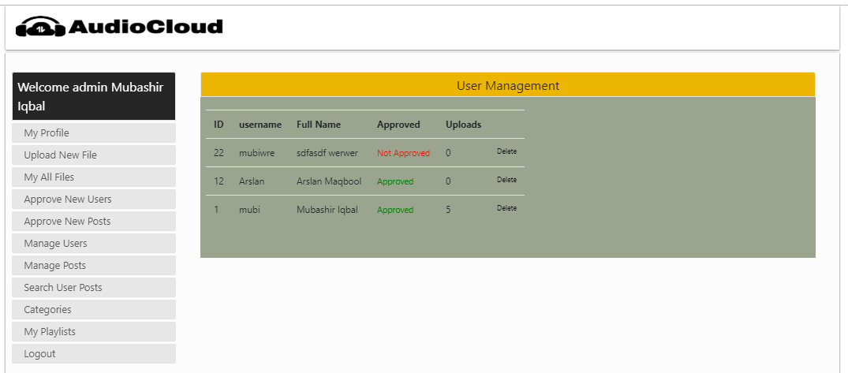

3.9.18 Admin Adding and Deleting Category Page

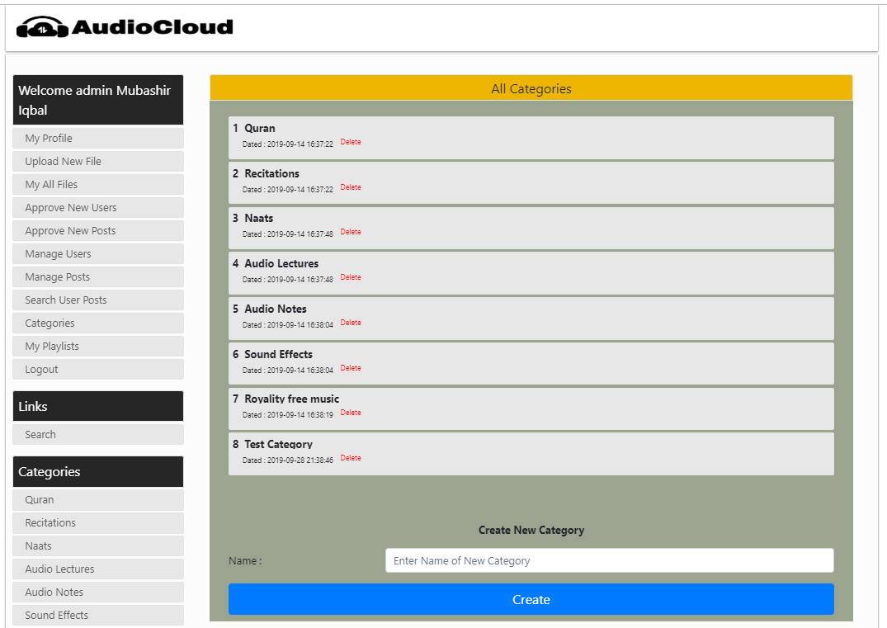

3.9.19 Admin Search User Post by User-ID Page

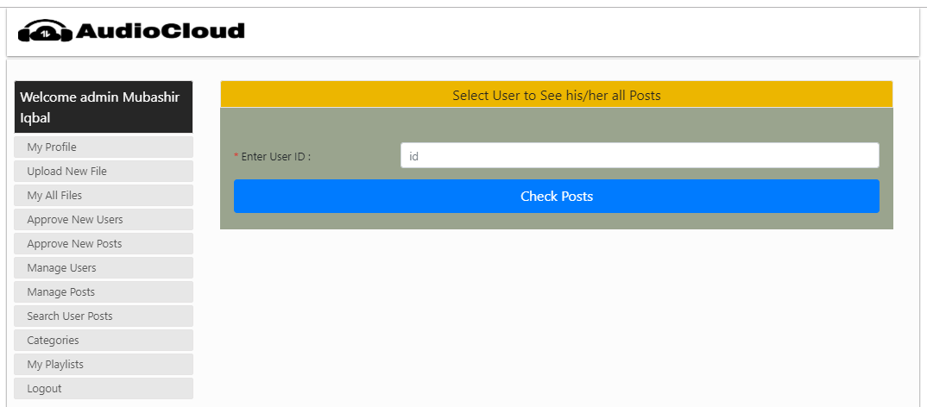

**CHAPTER 4**

Development

4.1 Development plan (Architecture Diagram)



**REFERENCES**

**Mubashir Iqbal (BC140400342)**

**&**

**Arslan Maqbool (BS140401325)**

**5 October 2019: AudioCloud**

**VU Wahcantt.**

**APPENDIX**

**A Project Report on**

**AudioCloud**

**For**

**Virtual University**

**By**

**Mubashir Iqbal (BC140400342)**

**&**

**Arslan Maqbool (BS140401325)**

**In fulfillment of Graduate Program in Computer Sciences**

**Virtual University of Pakistan**

**(2019)**